MATLAB HOMEWORK 1

 | >> m = -1:0.3:13  Exercise 1.1 By examining the output, explain what the previous command did. (You need not include the output in your Word document.) How do you think would MATLAB respond if you type m(33)? Try it.
MATLAB created a list of values from -1 to 13 in increments of 0.3.
Thus, the entered command syntax can be summarized by: list = begin:increment:end, where list is the name of the list, begin is the number to begin with, increment is the value of the interval, and end is the ending number.
m(33) would yield the 33rd entry, which turns out to be 8.6000, as expected from the expression: -1+32*0.3.
In general, m(n)=-1+(n-1)*0.3.

Exercise 1.2 Suppose we want to evaluate
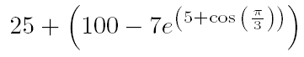
Enter the command
>> z = 25-(100-7exp(5+cos(pi/3))
You will get an error message. Use the up-arrow to bring this line back and then correct the error(s). (Hint: Good things to check are multiplication and parentheses.)
The original command and output:
>> z = 25 +(100-7exp(5+cos(pi/3))
??? z = 25 +(100-7exp(5+cos(pi/3))
|
Error: Missing variable or function.
The corrected command and output includes an extra ) and *:
>> z = 25 + (100-7*exp(5+cos(pi/3)))
z =
-1.5878e+003

Exercise 1.3 Graph the function g(x) = sin(x)/x on the interval [-20, 20] with fplot and then ezplot. Include the MATLAB code you used. Then paste these graphs into your Word document. To copy the graph bring its window to the front and choose the menu option Edit -> Copy Figure. Which method seems to produce a better graph in this case?

Here’s the function definition:
>> g=inline('sin(x)/x')

g =

Inline function:
g(x) = sin(x)/x

The result of fplot:
>> fplot(g,[-20,20])
>> title('fplot of g(x)=sin(x)/x')
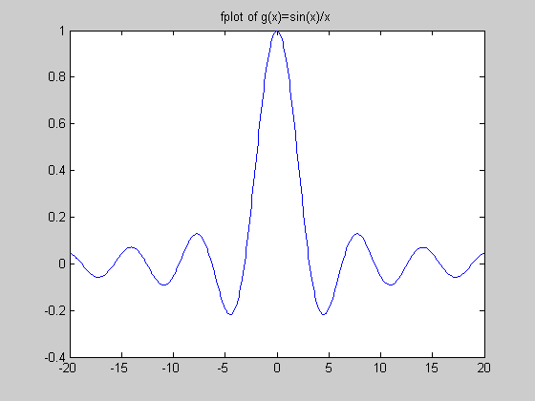

The result of ezplot:
>> figure
>> ezplot(g,[-20,20])
>> title('ezplot of g(x)=sin(x)/x')
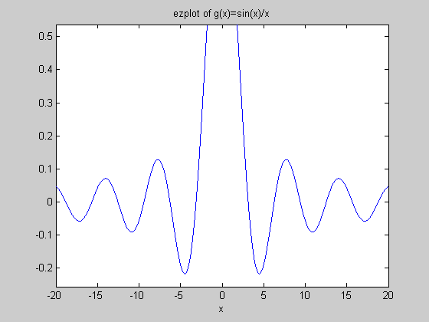
Interestingly, fplot seems to produce a better figure, since it shows the maximum at x=0. This makes sense, since its bounds for ymin and ymax are huge (on the order of 10^6), as seen in the example---and sinc(x) does indeed blow up at the origin!

Exercise 1.4 MATLAB's cumulative sum command is convenient to form these partial sums:
>> s = cumsum(a)
Using the output, answer Question B. (Remember, the coach is standing at the 100 meter mark. Also you should assume Xeres turns to face her coach when she stops.)
If Xerxes gives up the first time she’s within 1 m of her coach, how many times has she turned around?
s(7)=100.7813 m, which is within 1 m of 100 m. Counting the time she’s turned around to meet her coach after her 7th run, this would be 8 turns. (She has to turn around an extra time because she is not facing him after the 7th run.)

Exercise 1.5 Go ahead and include the resulting graph.
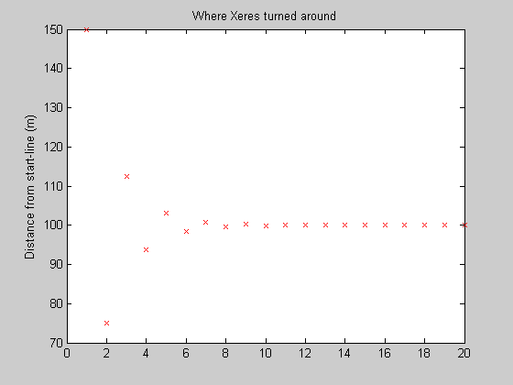
The above graph shows the s values for twenty runs. The graph below shows the s values near the critical point, at s(7), which is within 1 m of 100m.
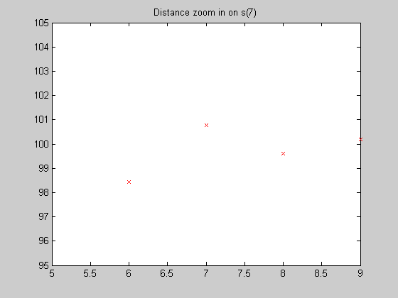
Distance from start-line (m)

Exercise 1.6 There is a formula for the sum of a geometric series:
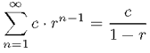
which holds when |r| < 1. In the current situation identify c and r based on the formula for the a(n) (found above Remark 1.3). Use MATLAB to evaluate c/(1-r) in this case. This will give us the sum of all the a(n). (The answer should not be a surprise considering the set-up of the problem.)
Each term is defined by a(n) = 150(-1/2)^(n-1), and thus c = 150, r = -1/2. Thus, one evaluates to get (after an infinite sum) exactly the original distance the coach intended for her to run (to wit: 100 m):
>> 150/(1+1/2)

ans =

100

Exercise 1.7
(a) Without doing any work, do you think the answer to Question C is yes or no?
(b) Let us repeat Exercise 1.6 for the infinite sum of the b(n). To do this, we can figure out the formula for b(n), and then identify the new c and r as in Exercise 1.6. This will give us the sum of all the b(n), thereby answering Question C.
- Without doing any work at all, I believe it’s yes. My ansatz is based on the fact that the sum is proportional to (1/2)^(n-1), and since one knows that sums of the form (1/x)^n, where n>1, converges, (1/2)^(n-1) should also converge since each term of 1/x^n gets smaller than each term of (1/2)^(n-1) – this isn’t formal or rigorous, but it’s a rough approximation I did (without writing anything down) to an inequality that should hold, thus I consider it doing no work at all.
- The sum is now |a(n)|=150(1/2)^(n-1), and thus the coefficients are c=150 and r=1/2:
>> 150/(1-1/2)

ans =

300

Exercise 1.8 Describe what would have happened if Xeres' coach had said to give 200 percent to every run. What about 201 percent?
For 200% every run, the geometric series would not converge, as r=1. 201% would not converge either as (1-201/100)= -1.0100, whose absolute value is greater than 1. Thus, for both percentages, Xeres would never get to her 100m mark.

