MATLAB HOMEWORK 2

 | Exercise 3.1 Explain how the above diagram confirms that (3) is the solution to (2). Also explain how the different constants C manifest themselves.
Each tiny line segment represents the tangent line at a particular point of the solution. A bunch of these tiny lines together represents a direction field. The slope field is formed by the derivative with respect to x of Equation (3). This is just x. Each tiny line is formed by the slope at that point. For example, the slope at the point (x,y)=(1,1) is just dy/dx=x=1. Similarly, a slope at point (x,y)=(2,4) is just dy/dx=x=2 (the tiny line at that point becomes more slanted than that at x=1). In general, the slope at point (x,y) is just x – the slope has only x-dependence, and thus varies only with x, hence the isoclines in the direction field. Since the slope has no y-dependence, each tiny line along a column (y-direction) is the same as that of its neighbors along the same column. The constants C manifests themselves from the boundary condition; once y(a)=y0 is set, C is uniquely(?) determined.

Exercise 3.2
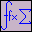 | - Sketch (by hand, without using MATLAB) the direction field of the following differential equation: dy/dx = -y.
 | - Also sketch the direction field for the differential equation dy/dx = x² + 1.

Exercise 3.3
(a) In this exercise, we are going to use DFIELD to plot the direction field of (4). That can be done by entering the following values into the DFIELD setup window. In the boxes under the words "The differential equation" enter y' = (exp(-x) - y)*(exp(-x) + 1 + y). (Note that y goes in the left box, and (exp(-x) - y)*(exp(-x) + 1 + y) goes in the right box.) In the independent variable box enter x. For now we are going to leave the parameters and expressions boxes empty and we are going to let the display window section alone. Click on the Proceed button. Now click in a few places on the plot. What are the lines which DFIELD has drawn? Also, use Options -> Keyboard input from the menu on the display window, enter the values x = 2 and y = 3 and click Compute. To include plots in your write-up, use Edit -> Copy Figure and paste the plot into the Word document which you intend to hand in.

Note: the octagon denotes the point (2,3).
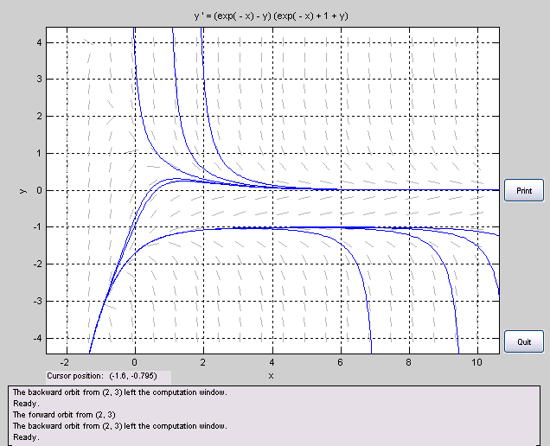
The lines dfield draws are solution curves to the differential equation that match the given “initial condition,” i.e., passes through the coordinate, (x,y). (I say “initial condition” because x can be seen as a time parameter, but it is not explicitly assumed.)

- Considering how complicated a differential equation (4) appears to be, what do you think is the utility of plotting direction fields?
dfield is not a bad utility to have – it does the job of solving for the roots (to find the zero slope “isoclines”), limiting behavior, and even the non-limiting behavior. It draws all the lines for you! (That is, it methodically plots the direction-line or isocline at a bunch of points to produce the regional direction field.)
Exercise 3.4 Plot the direction field of (5). Suppose that the experiment also reveals that the initial value is about (1,1). As in Exercise 3.3, use Options -> Keyboard input to plot the solution passing through the point (1,1). (That is, use x = 1, y = 1 and click Compute.) Now click on points near (1,1) on the graph itself. Using these plots, think about what would happen if the initial value in the problem were not exactly (1,1)? Would this greatly affect what the solution looks like for this differential equation?
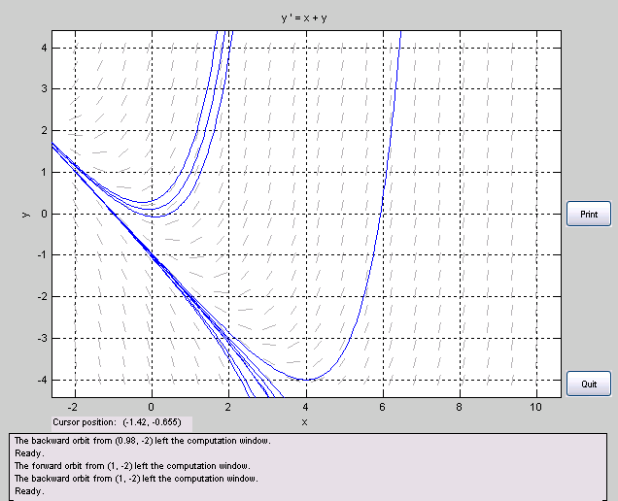
It appears that the behavior near (1,1) asymptotes to the diagonal line going through (0,-1). It appears that near (1,1), all solutions behave similarly, flowing downwards in a dip against the diagonal line asymptote. Were the deviation from (1,1) big, such as, say, (1,-2), then the solution would have completely different behavior for x->\infty.

Exercise 3.5 Plot the direction field of (6). Suppose that, according to our model, the initial value is about (0,0). Use Options -> Keyboard input to plot the solution passing though (0,0) and then click on a few points near it. If the initial value were not exactly (0,0), how would does this affect the solution?
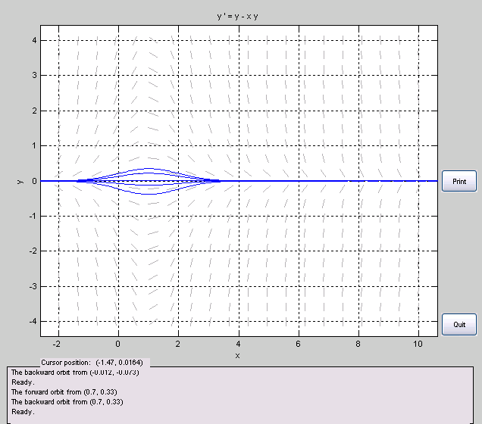
If the initial value were not exactly (0,0), but close to it, then near (0,0), the solution curve would “bump up” or “bump down,” as shown in the graph. However, it seems that all solutions near (0,0) have the same limiting behavior at infinities, as the exact (0,0) solution.

Exercise 3.6 Enter the above equation verbatim into DFIELD. In the parameters and expressions section enter A = 1 and k = 3. Plot the direction field and include it in your Word document. Plot the direction fields for different values of A and k (keep one of them constant while varying the other) and click on the direction field to plot some solutions for each of these values. What properties do you think A and k represent in real life? (Think about the temperature at which the solutions stabilize, and how fast they approach this temperature.) Note: the independent variable is now t so be sure to make the corresponding change in the DFIELD setup window.
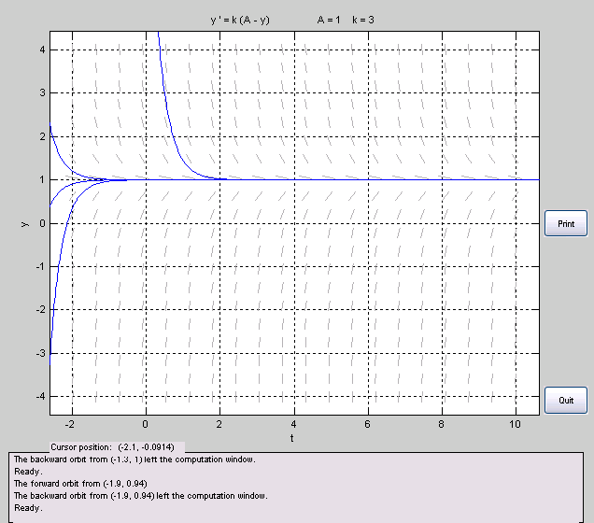
k looks like it represents the fastness or slowness of the temperature change. The bigger k is, the faster the change; smaller it is, the smaller the temperature change. A could be the ambient temperature or the room temperature, for example.

Shown are two different direction fields. The slowness/fastness is at k=3, but the A values have been changed. Thus, the equilibrium occurs at different points. Equilibrium occurs at y=1 for the top graph, and y=3 for the bottom graph.
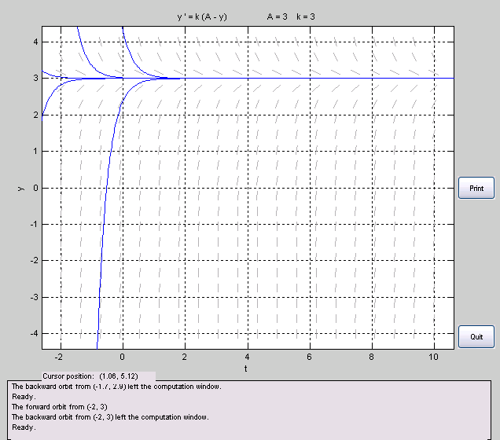

Let us try to figure out how long it will take to defrost a frozen chicken breast in the fridge, which keeps a constant temperature of 42°F. The succulent skinless boneless chicken breast has been in the freezer so its temperature is uniform at -5°F.
Exercise 3.7
(a) Recall that an initial value problem consists of a differential equation along with an initial condition. Write out the initial value problem which we must solve here. (We already have the differential equation, so this means you need to find the appropriate initial condition.)
(b) To simulate the conditions in the fridge we must pick the parameters A and k judiciously. We'll suppose that k = 0.3. What do you think the value of A should be?
(c) Let us consider the chicken breast fully defrosted when its temperature reaches 40°F. How long does it take to defrost a chicken breast under the above conditions? A rough estimate from a direction field plot is sufficient. (Hint: You may need to adjust the size of the display window, using the minimum value of y and maximum value of y boxes in the setup window. Also you may find using Options -> Keyboard input useful when entering initial data.)
(d) How much time would be saved if the delicious chicken breast were thawed on the kitchen counter instead, given that room-temperature is around 70°F?

